CHURCH CHATTER
March, 2022
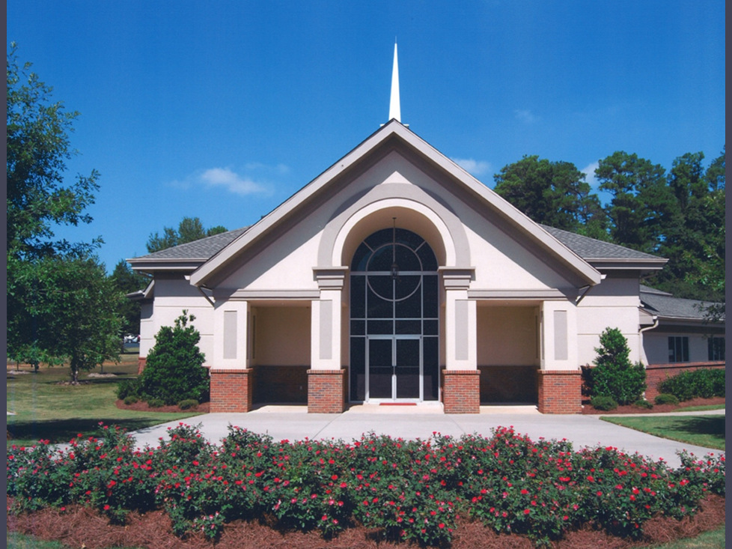
FIRST PRESBYTERIAN CHURCH OF JONESBORO
1842 Lake Jodeco Road
Jonesboro, GA 30236
770-478-8118
officemailfpcj@gmail.com
www.firstpresjonesboroga.org

A NOTE FROM THE PASTOR
How is it March already? It has been a great first few months, and I’ve loved getting to know you all and look forward to knowing you all better as time passes. Thank you all for being so welcoming and open, and for allowing me to be your pastor. Thank you also for helping plan, prepare for, and celebrate my ordination service at the end of last month. It was a deeply meaningful service for me personally, and it meant so much to be ordained with you all, at First Presbyterian Jonesboro. And, as I mentioned in the announcements last week, Jesse and I are looking forward to celebrating another meaningful milestone with you all as we welcome our son in August! FPCJ already feels like home, and I’m looking forward to the new things God will do through this community.
And as you may have noticed, we’re already doing a few new things this Lent! I want to thank those who were able to come out to the Ash Wednesday service of lament, and to thank you all for your willingness to learn a different sort of service. If you couldn’t make it in person, it is available to watch on the church’s Facebook page. Another new thing is our liturgy for the Lenten season, which comes from Rev. Sarah Are Speed at A Sanctified Art. Read more about them and our corporate Lenten practice on the following page.
I hope to continue meeting you all in person or by phone over the coming weeks, and I really would love it if folks stopped by church during the week to vent, pray, take a walk, or just chat. Let me know what ideas you all have for how FPCJ can be God’s hands and feet in the world and be on the lookout for new fellowship and Christian education opportunities coming in the next few weeks. I’m excited for what has been so far, and excited to see what’s next!
Thanks and peace,
Rev. Joshua Woodsmith

WEDNESDAY NIGHT BIBLE STUDY! Beginning March 30th, we will meet from 5:15-6:15pm to discuss the Revised Common Lectionary scriptures for the week. This is a come as you are and come when you can type of study, just bring yourself and your Bible (whichever translation you choose).
QUARTERLY MOVIE DISCUSSIONS: Once a quarter, we will replace the weekly Bible study with a discussion of a movie that everyone is invited to watch sometime prior to the discussion. We’ll meet from 5:15-7pm and there will be snacks and drinks available. We show a few clips from the film to refresh our memories as we discuss. The first one will be May 4th and the movie is The Prince of Egypt – (it’s not just a kid’s movie!).

FULL TO THE BRIM
Much of the liturgical elements of our worship services throughout this season are written by A Sanctified Art’s Rev. Sarah Are Speed, a Presbyterian pastor and poet. A Sanctified Art is a team of artists, many of whom are ordained Presbyterian ministers, working to tie their various artistic practices into their ministries. Our liturgy is a part of their Lenten resources and is based around the theme of being “Full to the Brim,” a line that you will see and hear repeated many times over the next few weeks.

LENTEN PRAYER CROSS
Finally, we are doing a corporate Lenten practice as a church family this year. At the end of the awning in front of the church we have set up a cross with some flagging tape and markers. If you have prayers weighing on your heart at any time during this season, you are invited to write those prayers on a strip of flagging tape, however long a strip you need, and then tie or weave that prayer through the wire on the cross. By the time we come to Easter, the cross will hopefully be covered in our prayers, and we will fill in any blank spaces with flowers.

ONE GREAT HOUR OF SHARING
The PC(USA)'s four church-wide Special Offerings help share Christ's love with millions of people around the world. During the season of Lent we receive offerings to support One Great Hour of Sharing. Each gift supports efforts to relieve hunger through the Presbyterian Hunger Program, promote development through the Presbyterian Committee on the Self-Development of People, and assist in areas of disaster through Presbyterian Disaster Assistance. Read more about the life saving and life-changing work your gifts help provide by going to pcusa.org/oghs. Join others in sustaining the important ministries of One Great Hour of Sharing by giving online at pcusa.org/give-oghs or place your envelope in the offering plate at church.
FROM THE MAILBOX
Dear Church Family,
Thank you so much for all the love expressed towards us after the passing of my mother. All the cards, calls and prayers are greatly appreciated and have made this difficult time more bearable. We know she is much happier being reunited with my father and no longer in pain. I’ve always said I don’t know how people manage to get through life without having a church family to lean on and you are the best!
Love,
Laura and Mike Wigington

FLC Foyer Beautification
A huge “Thank You” to Carol Hatfield, Carol Abdo, Jane Luetkemeyer, Gwen Taylor, Debbie Woodward and Joan Fox for the clean-up and renovation to the Family Life Center Foyer entrance by the church office. It now presents a pleasant entry for our members and guest. We also honor our past and present pastors with pictures and dates of service mounted on the wall.

A big thank you to all who worked in the concession, baked cookies, brownies, brought in soft drinks, water and popcorn. It sure felt good to see a full house and a wonderful musical Godspell. Working together we made $1,653.70 to buy food for the backpack ministry!
Jane Luetkemeyer

ANNOUNCEMENTS AND UPCOMING EVENTS
EASTER LILIES: Easter Lilies will be placed in the sanctuary on Easter morning. If you would like to place one in memory or honor of someone, please complete the form that will be in the Narthex and place it in the collection plate. A donation of $15.00 is appreciated. Any money collected over the cost of the lilies will be donated to a worthy cause. Deadline to order is Sunday, April 10. You may also email the church with this information and mail your payment.
EASTER MORNING BREAKFAST: Congregational Care is planning a Casserole Breakfast Easter Morning. There will be a sign-up sheet on the bulletin board by the kitchen door next Sunday. The Breakfast will take place during the Sunday School hour.

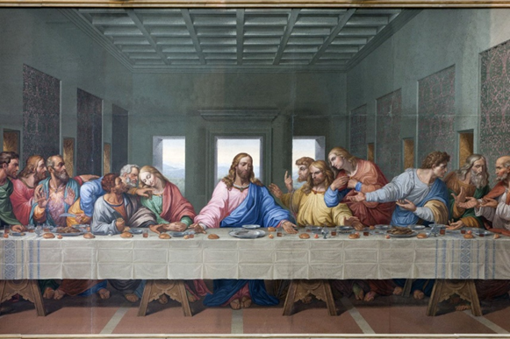
We will gather for a Maundy Thursday Tenebrae service April 14 at 6pm. This is always a meaningful time when we remember the Last Supper Jesus shared with his disciples before his crucifixion.

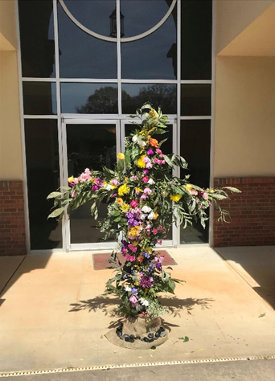
Remember to bring fresh flowers on Easter Sunday to decorate our cross.
Through the Lenten season, our cross will be displayed out front under the drive through awning for anyone who wishes to write a prayer and attach it to the cross. On Easter morning the cross will be moved to the front door and flowers will be added to fill in around the prayers.

HAPPY 100TH BIRTHDAY, ELOISE!

On Wednesday, February 2nd, Eloise Belle Isle, almost 100 years old, was treated to a surprise breakfast party at the Magnolia House and Gardens in Jonesboro. The normal first Wednesday of the month breakfast turned into a huge birthday party by the Magnolia House. Balloons and flowers decorated the tables and a wonderful buffet for all to enjoy made it a festive occasion. White chocolate strawberries were available for all to take home.
Thanks to Ruby White and the wonderful staff at the Magnolia House and Garden for making this wonderful event happen.
Eloise called Carol and Alan the morning of her birthday and said that she had stayed up until midnight to usher in her birthday. We are all looking forward to celebrating her next birthday!

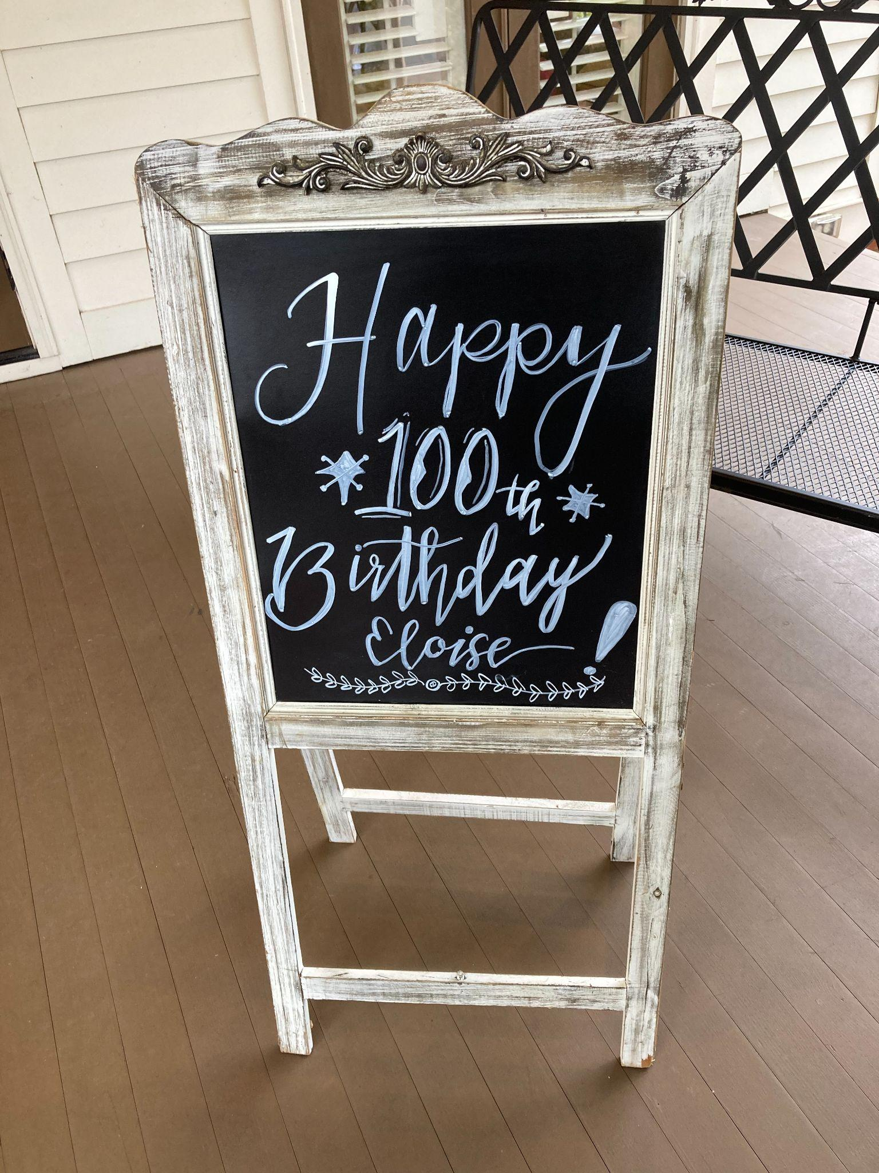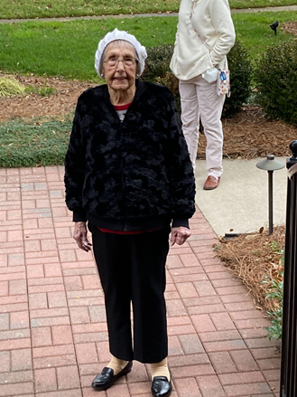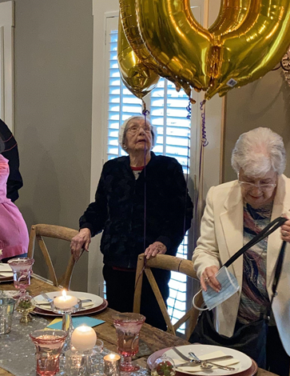
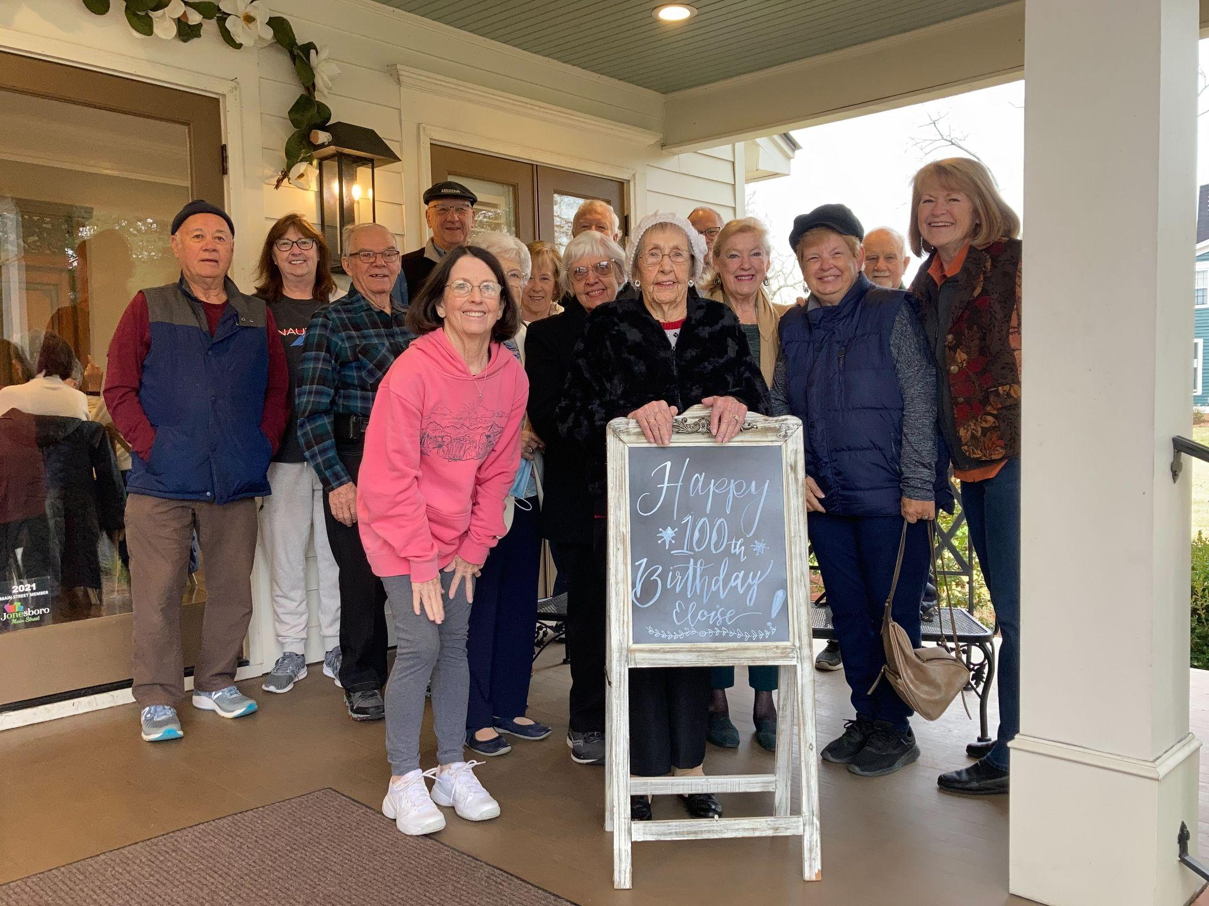

FIRST PRESBYTERIAN CHURCH OF JONESBORO
1843 Lake Jodeco Road
Jonesboro, GA 30236
770-478-8118
officemailfpcj@gmail.com
www.firstpresjonesboroga.org

***************************************

STAFF

PASTOR: Rev. Joshua Woodsmith
MUSIC DIRECTOR: Blake Hardy

****************************

SESSION

Pat Hockett, Clerk
Raymond Baggarly
Alan Bergmann
Walter Harryman
Jane Luetkemeyer
Laura Wigington
Debbie Woodward

