CHURCH CHATTER
May, 2022
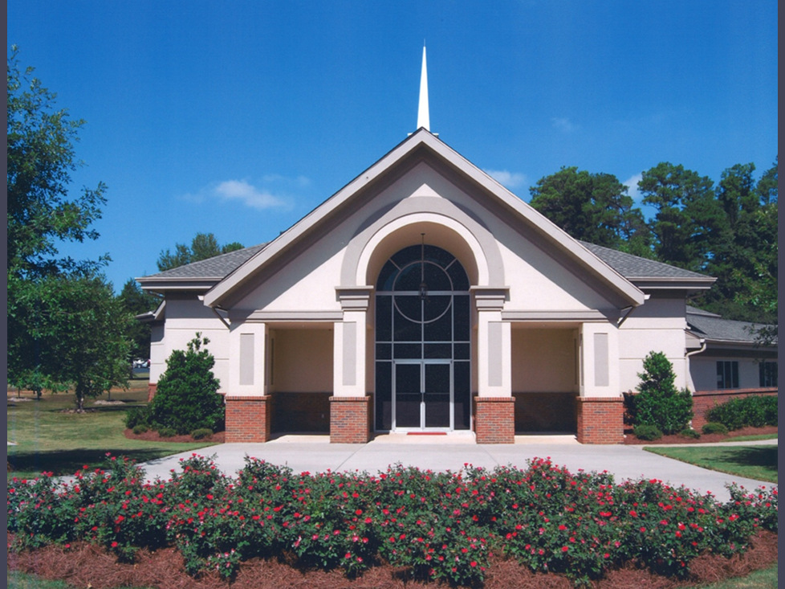
FIRST PRESBYTERIAN CHURCH OF JONESBORO
1842 Lake Jodeco Road
Jonesboro, GA 30236
770-478-8118
officemailfpcj@gmail.com
www.firstpresjonesboroga.org

A NOTE FROM THE PASTOR
Somehow we have already made it through Lent, Easter, and a baptism, and I have officially been with you all for five months. Time really does fly, it seems. We’ve continued church work days, the Backpack Ministry for Suder Elementary and related concession stand at FPP productions, Presbyterian Men’s and Women’s lunches and meetings, re-started weekly Bible Studies, and started a quarterly Movie Discussion Night. We’re working on hosting a craft fair in October and will be working through a different lectionary series during the summer months, and I am looking forward to hearing from you all about more things we could do as a church family.
As you all probably know by now, Jesse and I officially bought a house and moved last month, to a house with a large yard that inspired more than one church member to say, “I see a riding lawnmower in your future”. Thank you to the members of the mission team who took time out of their schedules to help us move. We could not have done it without all of you, and we appreciate it so much. In just a few months (early August) Jesse and I are expecting a baby boy, and I have felt so grateful to and supported by you all as we start these new and very big chapters in our life.
Thank you all for being the family of God, and let us continue to do the work of loving God and our neighbors as best we can. If at any point you would like to chat or get a meal or a coffee, simply let me know, and if we’ve not yet met then please do reach out to me via email or phone, or by dropping by the church during office hours.
Thanks and peace,
Rev. Joshua Woodsmith
ANNOUNCEMENTS AND UPCOMING EVENTS
Office Hours
Josh will be out of the office on the 16th and 17th of May, but normal office hours of Monday and Tuesday morning from 9-12 and Wednesday afternoons from 1-4 will continue after that.
Weekly Bible Study
Each Wednesday at 5:15 we have a Bible Study focusing on the scripture passages for the coming Sunday. We talk about differences between translations, the historical context of the passages, how the focal passages fit into the messages of scripture as a whole, and more. We will be studying the weekly passages from the Revised Common Lectionary until Pentecost.

Quarterly Movie Discussion Night
Thanks to those who came out last Wednesday night to discuss and watch clips from the movie Prince of Egypt. We had good conversation around how film can humanize our depictions of biblical characters, how Moses’ story shapes other biblical narratives, and the possibilities of imagining what Moses’ childhood and young adulthood might have looked like. Our next movie discussion night will be Wednesday, July 20th, from 4:00-6:00, and we will be discussing the 1984 movie Places in the Heart.

Your Lenten Prayers
During the season of Lent, we all tied prayers to the cross in front of the church. For the Easter season, those prayers sit on our communion table, reminding us that God is always listening. Some of those prayers are included in the Prayers of the People each week, but all of them are heard by God.

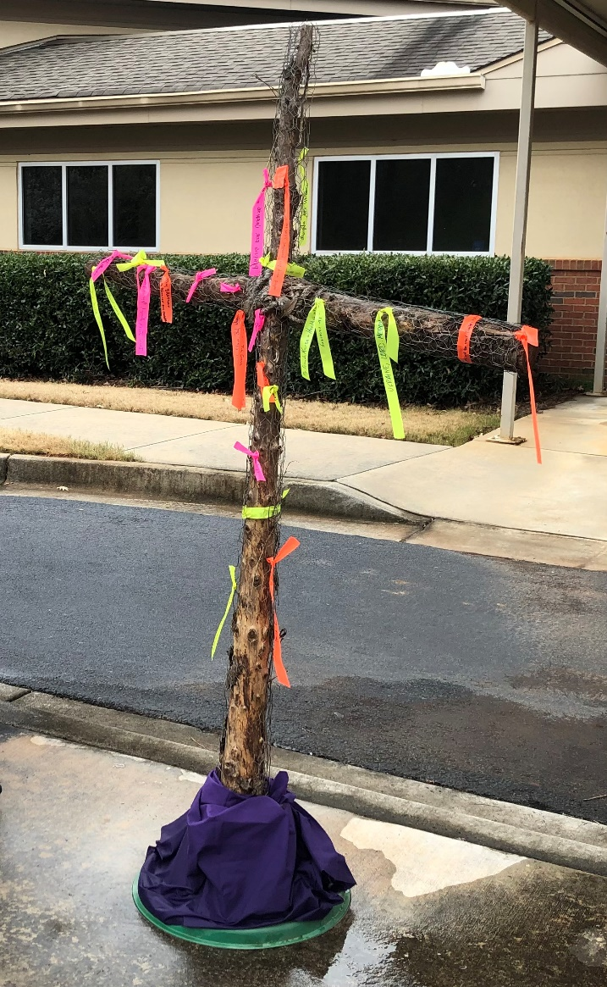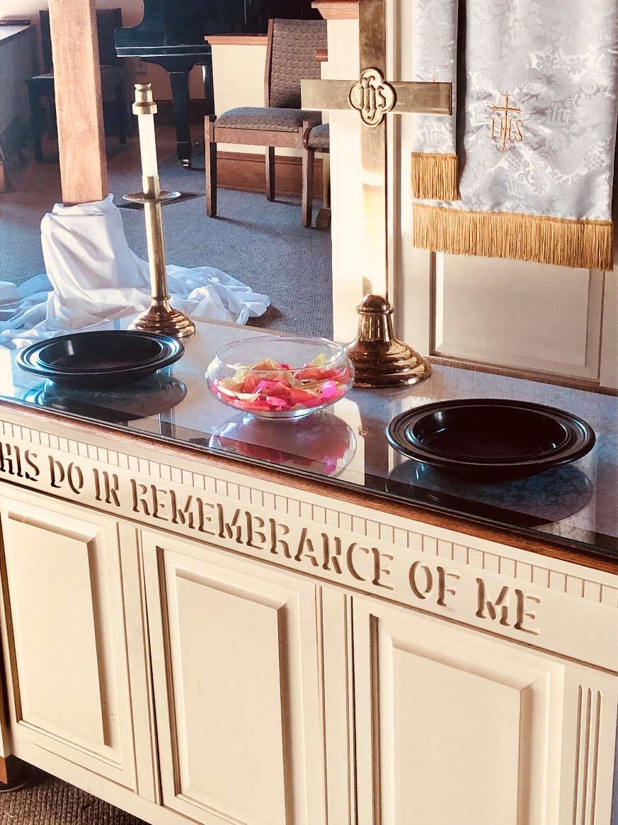

100th Anniversary of Presbyterian Women
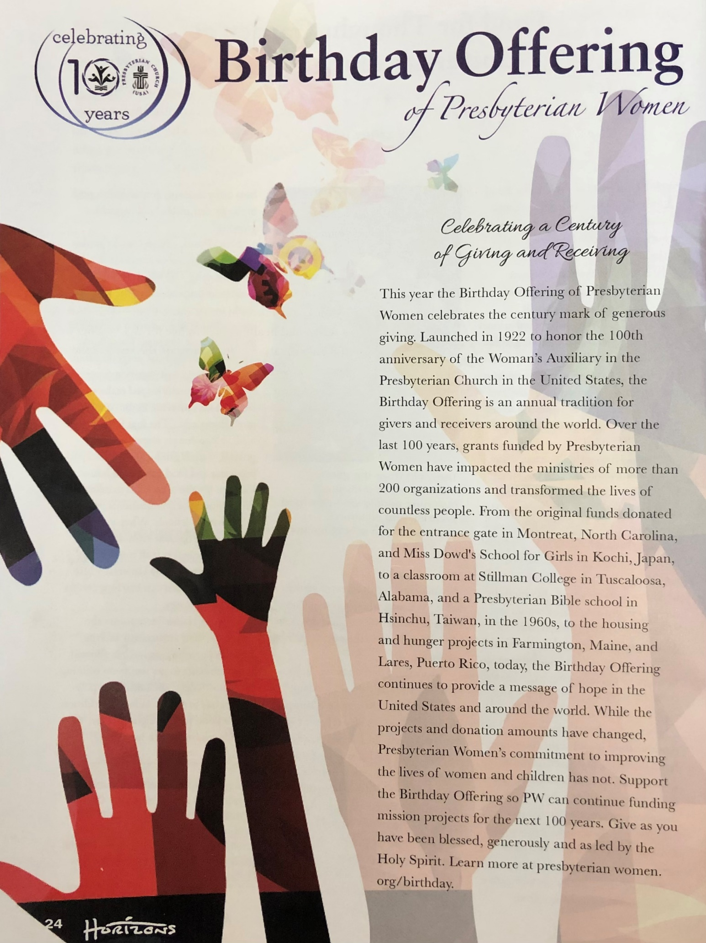
The Front Porch Players
Come out the next two weekends to support The Front Porch Players as they perform The Sweet Delilah Swim Club, or to work the concession stand and help us raise money to support the Suder Elementary Backpack Ministry. Sign up sheets for the concession stand are on the bulletin board beside the kitchen in the Family Life Center, and a synopsis of the play is below:
Five southern women, whose friendships began many years ago on their college swim team, set aside a long weekend every August to recharge those relationships. Free from husbands, kids, and jobs, they meet at the same beach cottage, the ”Sweet Delilah” on North Carolina’s Outer Banks to catch up, laugh, and meddle in each other’s lives. The Sweet Delilah Swim Club focuses on four of those weekends and spans a period of thirty-three years. As their lives unfold and the years pass these women increasingly rely on one another, through advice and raucous repartee, to get through the the challenges that life flings at them.
Summer Schedule Changes
Keep an eye out for a few changes as we head into the summer months, such as choir rehearsals going on hiatus after Pentecost, Bible Study time moving up to 4:00 on June 15th, and other potential shifts as we adjust to the rhythms of summer.

STAFF

PASTOR: Rev. Joshua Woodsmith
MUSIC DIRECTOR: Blake Hardy

****************************

SESSION

Pat Hockett, Clerk
Raymond Baggarly
Alan Bergmann
Walter Harryman
Jane Luetkemeyer
Laura Wigington
Debbie Woodward

